# Experiment No.: 05

**Two-Wire Level Transmitter**

|  |  |
| --- | --- |
| **Academic Year** | **: 2021-22 Sem : I** |
| **Class** | **: TY BTech Instrumentation & Control** |
| **Course Name** | **: Process Instrumentation** |
| **Course Code** | **: IC3231** |
| **Name** | **: Shaunak Deshpande** |
| **Division** | **: IC-C** |
| **Roll No.** | **: 39** |
| **G.R. No.** | **: 11911180** |

**Experiment No. : 5**

**Two wire Level Transmitter**

**Aim :** Characterize the given Level Transmitter On Virtual Lab

**Apparatus :** Two wire temperature Level transmitter(4-20mA), Digital Multimeter, power supply, etc.

### Theory :

A transmitter is a device which responds to a physical parameter and converts it into standard transmission signal. It sends the measured data from field to control room. In a process loop transmitters are used as a feedback device to the controller. There are mainly three types of analog transmitter 2-wire, 3-wire and 4-wire. In the two wire type same two wires are used for providing power supply and collecting control signal. This type of configuration is used when field transmitters are not self-powered or when the sensor is mounted far away from the measuring instrument. It can be connected to any temperature element and using suitable signal conditioning gives the electrical output in the range of 4-20mA. The devices that can be driven by 4-20mA signal can be connected in series with it. It reduces the number of wires need and the cost thus easing the maintenance but because of its low input impedance capability its limits the type and number of devices driven by the signal.

The transmitter will be ranged by a programming device, say for example an application where process levels need to be measured between 0-10 meters, the transmitter will be ranged 0-10 meters and thus give an output proportional to the level measured by the sensing element. 0 meter = 4mA, 10 meters = 20mA.

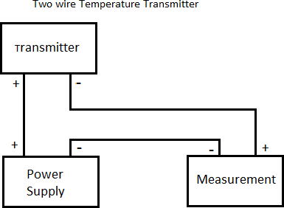

**Screenshots of the Tasks completed on the Virtual Lab:**

(Introduction, Configuration, Connections, Characterization, Calculations, Calibration, Final observation Table, Fault Finding, etc.)

